Section 09 70 00
INTERIOR GLASS FINISHES
**SPECIFIER NOTE**
Clear Hue Interior Glass Finishes
These sections are based on products distributed by Clear View Window Tinting, LLC (DBA Clear View Window Film Solutions), and Clear Hue custom printed design products for interior glass surfaces.
Clear View Window Tinting, LLC is located at:
1720 Allied Street
Charlottesville, VA 22903
434.996.8468 (office)
434.806.2088 (owner)
Email: Request for Info – sales@clearhue.com (mailto: sales@clearhue.com)

- GENERAL
  - SECTION INCLUDES
    - Custom UV Print Window Film
  - RELATED SECTIONS
**SPECIFIER NOTE** Delete non-relevant section(s) below: add others as required.
    - Section 08800 – Glazing: General Glazing applications to receive interior design glass finishes
    - Section 08900 – Glazed Curtain Walls: Curtain Walls to receive interior design glass finishes
  - REFERENCES
**SPECIFIER NOTE** Delete references below that are not required by the edited sections.
    - CPSC Part 1201 – Safety Standard for Architectural Glazing Materials.
    - International Window Film Association (IWFA) – Architectural Visual Inspection Standard for Applied Window Film as Adopted by The IWFA May 15, 1999.
    - ASTM G 26 – Standard Practice for Performing Accelerated Outdoor Weatherizing for Non-metallic Materials Using Concentrated Natural Sunlight.
  - PERFORMANCE REQUIREMENTS
    - Flammability (performance to ASTM E84):
      - Flammability: Surface burning characteristics when tested in accordance ASTM E 84:
        - Flame Spread Index: 25, maximum.
        - Smoke Developed Index: 450, maximum.
    - Source Limitations: Provide each type of product from a single manufacturing source to ensure uniformity.
  - SUBMITTALS
    - Submit under provisions of Section 01 30 00
    - Product Data: Manufacturer’s data sheets on each product to be used, including:
      - Preparation instructions and recommendations
      - Storage and handling requirements and recommendations.
      - Installation methods.
    - Verification Samples: For each finish product specified, two samples representing actual product, color, opacity and design.
  - QUALITY ASSURANCE
    - Manufacturer Qualifications: All primary products specified in this section will be supplied by a single manufacturer with a minimum of ten (10) years’ experience.
    - Installer Qualifications: All products listed in this section are to be installed by a single installer with a minimum of (5) years’ demonstrated experience in installing products of the same type and scope as specified.
      - Provide documentation that the installer is authorized by the Manufacturer to perform Work specified in this section.
      - Provide a commercial building reference list of five (5) properties where the installer has applied interior design window film. This list will include the following information:
        - Name of building.
        - The name and telephone number of a contact.
        - Type of glass.
        - Type of film.
        - Amount of film installed.
        - Date of completion.
    - Mock-Up: Provide a mock-up for evaluation of surface preparation technique, application workmanship, and confirmation of the design intent.
      - Finish areas designated by Architect.
      - Do not proceed with remaining work until workmanship, color, opacity, design, and sheen are approved by Architect.
      - Refinish mock-up area as required to produce acceptable work.
  - DELIVERY, STORAGE AND HANDLING
    - Store products in manufacturer’s unopened packaging until ready for installation.
    - Store and dispose of hazardous materials, and materials contaminated by hazardous materials, in accordance with requirements of local authorities having jurisdiction.
  - PROJECT CONDITIONS
    - Maintain environmental conditions (temperature, humidity, and ventilation) within limits recommended by manufacturer for optimum results. Do not install products under environmental conditions outside manufacture’s recommended limits.
    - Surface temperature: Do not apply glazing film when surface temperature is less than 40 degrees Fahrenheit.
    - Prior to installation, the glass and frames shall be inspected for surface contamination, damage, or other defects that may adversely affect the performance of the glazing film.
- PRODUCTS
  - MANUFACTURER
    - Acceptable Manufacturer: Clear View Window Film Solutions, 1720 Allied Street, Charlottesville, VA 22903, Tel: 434-996-8468, Fax: 434-295-7855, www.clearviewtint.com, info@clearviewtint.com
    - Substitutions: Not permitted
  - CUSTOM UV PRINT WINDOW FILM
**SPECIFIER NOTE** Delete below product(s) not required for project. Add additional paragraphs for each color or design in your project.
    - CH-1000 Optically Clear window film with printed graphics
      - Top Coat: High performance scratch resistant UV ink-jet receptive topcoat
      - Thickness: 2.0 mil
      - Color: Optically Clear
      - Construction: Polyester (PET)
      - Adhesive: Permanent Pressure Sensitive
      - Liner: 2.0 mil PET
      - Widths: 61” and 72”
      - Reference: Part 3 Design Intent Inclusions, Paragraph 3.1 through 3.2
      - Provided by/Point of contact:
Clear View Window Film Solutions
1720 Allied Street, Charlottesville, VA 22903
434-806-2088
darin@clearviewtint.com
- DESIGN INTENT INCLUSIONS
**SPECIFIER NOTE** This paragraph related to Paragraph 2.2 (A) #8 above. Design Intent inclusions are very important to successful interior glass finishing. Not all of the necessary detailed information becomes known until certain aspects of the designs is completed by your project customer and the project interior and/or graphic designer. Original design inclusion may become modified after design mock-up is implemented and a final design review and approval is completed.
  - BASIC INFORMATION INCLUSIONS REQUIRED FOR CUSTOM UV PRINT WINDOW FILM
    - Design/Artwork
**SPECIFIER NOTE** We offer a variety of standard designs that are good “out-of-the-box” solutions that require little input to specify for your project. You can choose a Standard design from our online catalog (https://clearhue.com).
If your project includes specific glass finish designs – insert design information and description(s), color choices from an applicable Pantone Color Chart, and include design image(s) for your project in a digital Vector format file.
We also offer optional in-house design resources that work with your projects selected interior and/or graphic designer in order to create custom designs.
    - Dimensions
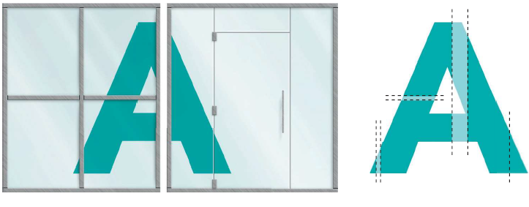
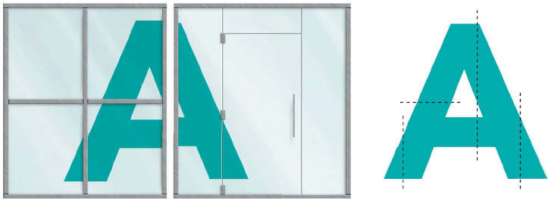
**SPECIFIER NOTE** Measuring glass surfaces for custom interior design glass finishes is critical. To facilitate the process and greatly improve the end result we offer our guide “Measuring Glass Surfaces” online at https://clearhue.com/architects, and included below.
CORRECT
INCORRECT
Artwork can be fitted during production so that once installed, the image alighs properly across the glass panels.
Artwork not properly sized and paneled during production, resulting in an out-of-alignment install.
      - Each Glass Surface Area Unit
**SPECIFIER NOTE** Each pane and/or panel of glass is printed separately. These include 2” of bleed and must be trimmed during installation. The custom printed products are available in widths up to 70”. Therefore, glass panels that exceed 70” in height and width would require a seam. Insert the individual glass surface dimensions for each pane and/or panel. Include applicable drawing references. These are critical to ensuring the finished custom design product will align continuously across the full section of the glass surface.

        - Drawing Reference
        - Width x Height (inches)
      - Mullions or Dividers
**SPECIFIER NOTE** Delete this section if not applicable to your project. Otherwise, Insert the width and height of all mullions or dividers. Include applicable drawing references. These are critical to ensuring the finished custom design product will align continuously across the full section of the glass surface.
        - Drawing Reference
        - Width x Height (inches)
    - First Surface/Second Surface
**SPECIFIER NOTE** Insert installation requirement with respect to surface. Indicate a surface selection for each contiguous glass surface.
First surface refers to installation directly to the outside of the glass surface. Second surface refers to installation on the inside glass surface.
  - CUSTOMIZATION OPTIONS
**SPECIFIER NOTE** Delete below option(s) not required for your project: add additional design requirement(s) if applicable. Specify design option choices.
    - Ink Combinations – White, Color and Clear Inks can be combined. Each customization yields a different effect. These combinations are:
      - Color Ink Only – Inherently frosted in appearance, allows diffused light to pass through. Can also be used to rea a neutral frosted glass effect.
      - White Ink Only – More opaque than color inks, appearing frosted in nature.
      - Color + White Inks – Use in combination for both aesthetics and to add opacity to the colors. Typically, a single layer of color backed by a single layer of white (viewable on one side of the glass), or a layer of white sandwiched between two layers of color (viewable on both sides of the glass).
      - Varnish – Created by adding a gloss effect to color inks, resulting in glossy, transparent stained-glass effect.
    - Opacity – The degree to which the ink completely blocks out light. Low opacity if very transparent, while high opacity allows very little light pass-through.
      - White ink is inherently very opaque. White ink is ideal for controlling opacity and prints opaque more so than expected, for best results when customizing err on the lighter side.
      - Color inks are inherently translucent though dark colors opacity is slightly more than light colors.
      - Controlling opacity is done by adding white ink to color ink.
    - Gradients – A print that starts as one color or opacity and fades to a different color or opacity.
      - Gradients of White Ink – always fade from one opacity to another opacity. In a gradient that transitions from white ink to unprinted clear film can be noticeable.
      - Gradients of Color Ink – always allow light to pass through, unless backed by white ink.
- EXECUTION
  - PREPARATION
    - Clean surfaces thoroughly prior to installation.
    - Prepare surfaces using the methods recommended by the manufacturer for achieving the best result for the substrate under the project conditions.
  - INSTALLATION
    - Install in accordance with manufacturer’s instructions.
    - Cut film edges neatly and square at a uniform distance of 1/8 inch (3 mm) to 1/16 inch (1.5 mm) of window sealant. Use new blade tips after 3 to 4 cuts.
    - Spray the slip solution, composed of one capful of baby shampoo to 1 gallon of water, on window glass an adhesive to facilitate proper positioning of film.
    - Apply film to glass and lightly spray film with slip solution.
    - Squeegee from top to bottom of window Spray slip solution to film and squeegee a second time.
    - Bump film edge with lint-free micro fiber towel around edge with a 5-way tool.
    - Upon completion of film application, allow 30 days for moisture from film installation to dry thoroughly, and to allow film to dry flat with no moisture dimples when viewed under normal viewing conditions.
  - FIELD QUALITY CONTROL
    - After installation, view film from a distance of 10 feet (3 meters) against a light-colored background. Ensure appearance is uniform without streaks, bands, thin spots, and pinholes in accordance with the IWFA Architectural Visual Inspection Standard for Applied Window Film as Adopted by the IWFA May 15,1999.
    - If installed film does not meet these requirements, remove and replace with new film.
  - CLEANING AND PROTECTION
    - Remove left over material and debris from Work area. Use necessary means to protect film before, during, and after installation.
    - Inspect installation. Verify that it is complete and complies with requirements and manufacturer’s instructions to provide specified anti-intrusion requirements. Correct deficiencies.
    - Clean glass following installation.
    - After application of film, wash film using a soapy water solution, 30 days after application. Do not use abrasive type cleaning agents, abrasive sponges, or paper towels to avoid scratching film. Use synthetic sponges or soft micro fiber clothes.

--- END OF SECTION ---

